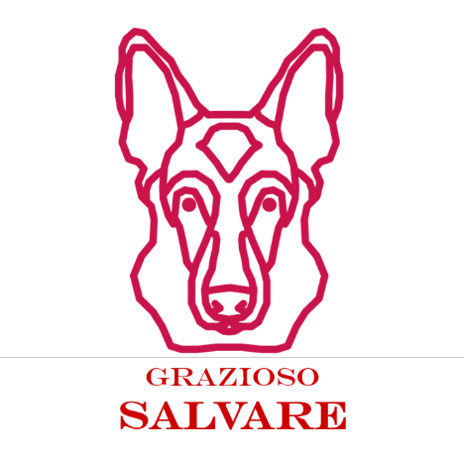

Grazioso Salvare Rescue Dashboard
README
Jairo Figueroa Rojas
CS 340: Client/Server Development
Southern New Hampshire University
06/21/ 2026

About the Project
Grazioso Salvare is a rescue-animal training organization that needs an easy way to identify dogs suited for different search-and-rescue roles. This project is an application that will connect the database of animals from Austin Animal Center Outcomes found on MongoDB. Users can use filters to find appropriate animals, check them out using the table, see their breed distributions in the chart, and map the animal.
Project files: ProjectTwoDashboard.ipynb, animal_shelter.py, and Grazioso Salvare Logo.png.

Motivation
This project aimed to create an intuitive client/server application that would decrease the time and effort spent on finding potential candidates for rescue dogs. The dashboard uses the model-view-controller pattern where the MongoDB database is the model, the components from the Dash library constitute the view, and the dash callbacks serve as the controller. Furthermore, the dashboard also makes use of the already written AnimalShelter CRUD module in order to keep everything consistent with the database interaction.

Required Functionality
• Filters that allow for interaction with Water Rescue, Mountain or Wilderness Rescue, Disaster or Individual Tracking, and Reset.
• A table that changes according to the chosen filter.
• A geolocation map that changes according to the filtered table and the selected row.
• Another dynamic chart that indicates the breeds distribution.
• The Grazioso Salvare logo that directs to the SNHU website.
• A creator identifier
• User-friendly table options like pagination, filtering, sorting, and row selection.

Getting Started
The project was created using Jupyter Lab on Codio. It requires that the MongoDB service be started, the Austin Animal Center Outcomes data be loaded in the aac database, and aacuser account has read access on animals collection.
Installation and Setup
- Launch the Codio project and MongoDB.
- Check whether the aac database has the animals collection along with the records of Austin Animal Center Outcomes.
- Move the files ProjectTwoDashboard.ipynb, animal_shelter.py, and Grazioso Salvare Logo.png to the same directory.
- Verify that the following packages for Python programming are installed: pymongo, pandas, dash, jupyter-dash, plotly, and dash-leaflet.
- Load the file ProjectTwoDashboard.ipynb in the JupyterLab environment.
- Add the valid MongoDB username and password in the notebook.
- Execute the code in the notebook and click on the generated URL using the app.run_server() function.

Tools Used
- MongoDB: Stores animal outcome documents.
- PyMongo: Connects Python to MongoDB.
- AnimalShelter CRUD module: Provides create, read, update, and delete methods.
- Dash / JupyterDash: Creates the dashboard and handles callbacks.
- Pandas: Converts query results to DataFrames.
- Plotly Express: Creates the pie chart.
- Dash Leaflet: Creates the geolocation map.
- Codio / JupyterLab: Development and testing environment.

Usage
After opening the dashboard, choose any of the radio buttons for rescuing. The callback uses the respective query to get the result using the AnimalShelter read function. Data will be updated in the table based on the results obtained and then, after that, the chart and map will be updated with the help of the data present in the table. Choose a row in the table to view the animal’s details on the map.

Rescue Filter Criteria(Based on Rescue Type)
Rescue Type | Preferred Breeds | Preferred Sex | Training Age
Water Rescue | Labrador Retriever Mix; Chesapeake Bay Retriever; Newfoundland | Intact Female | 26–156 weeks
Mountain or Wilderness Rescue | German Shepherd; Alaskan Malamute; Old English Sheepdog; Siberian Husky; Rottweiler | Intact Male | 26–156 weeks
Disaster or Individual Tracking | Doberman Pinscher; German Shepherd; Golden Retriever; Bloodhound; Rottweiler | Intact Male | 20–300 weeks
Reset | All records | All | All

Dashboard Features
- Interactive filter controls: There are four radio buttons that enable the client to change from rescue profiles and unfiltered view.
- Interactive data table: The data table allows pagination, native sort, filter, and single record selection.
- Breed chart: The pie chart makes use of the table records visible and shows top ten breeds in order to ensure the Reset view is legible.
- Geolocation Map: The geolocation map makes use of latitude and longitude columns and shows the marker, tooltip, and popup for the selected animal.

Testing
The dashboard was successfully evaluated through running the application, clicking on the generated URL, choosing all the necessary rescue filters, looking at the table records, and selecting one row from the table to make sure that the map changes.
• Reset shows the entire dataset.
• Water Rescue shows only those dogs that fit the necessary breeds, sex, and age category.
• Mountain or Wilderness Rescue shows only those dogs that fit the necessary breeds, sex, and age category.
• Disaster or Individual Tracking shows only those dogs that fit the necessary breeds, sex, and age category.
• The pie chart changes every time when a filter is chosen.
• When a row in the table is chosen, the map marker and its pop-up change accordingly.
• The logo and creator identification never disappear.

Dashboard Screenshots( with all different filters displayed)
Figure. Dashboard with the Reset filter selected
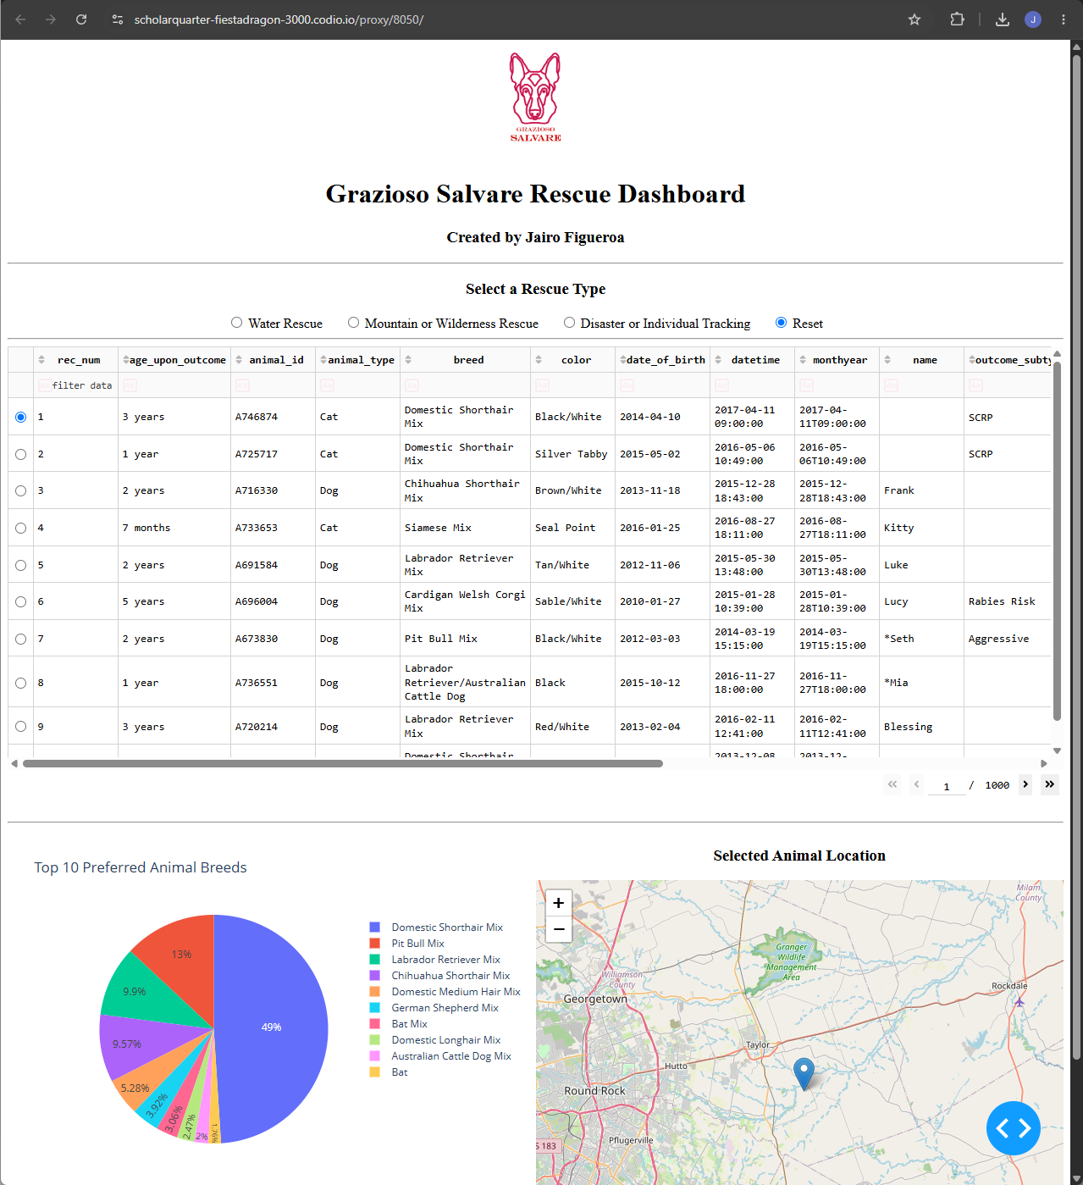
Figure. Dashboard with the Water Rescue filter selected
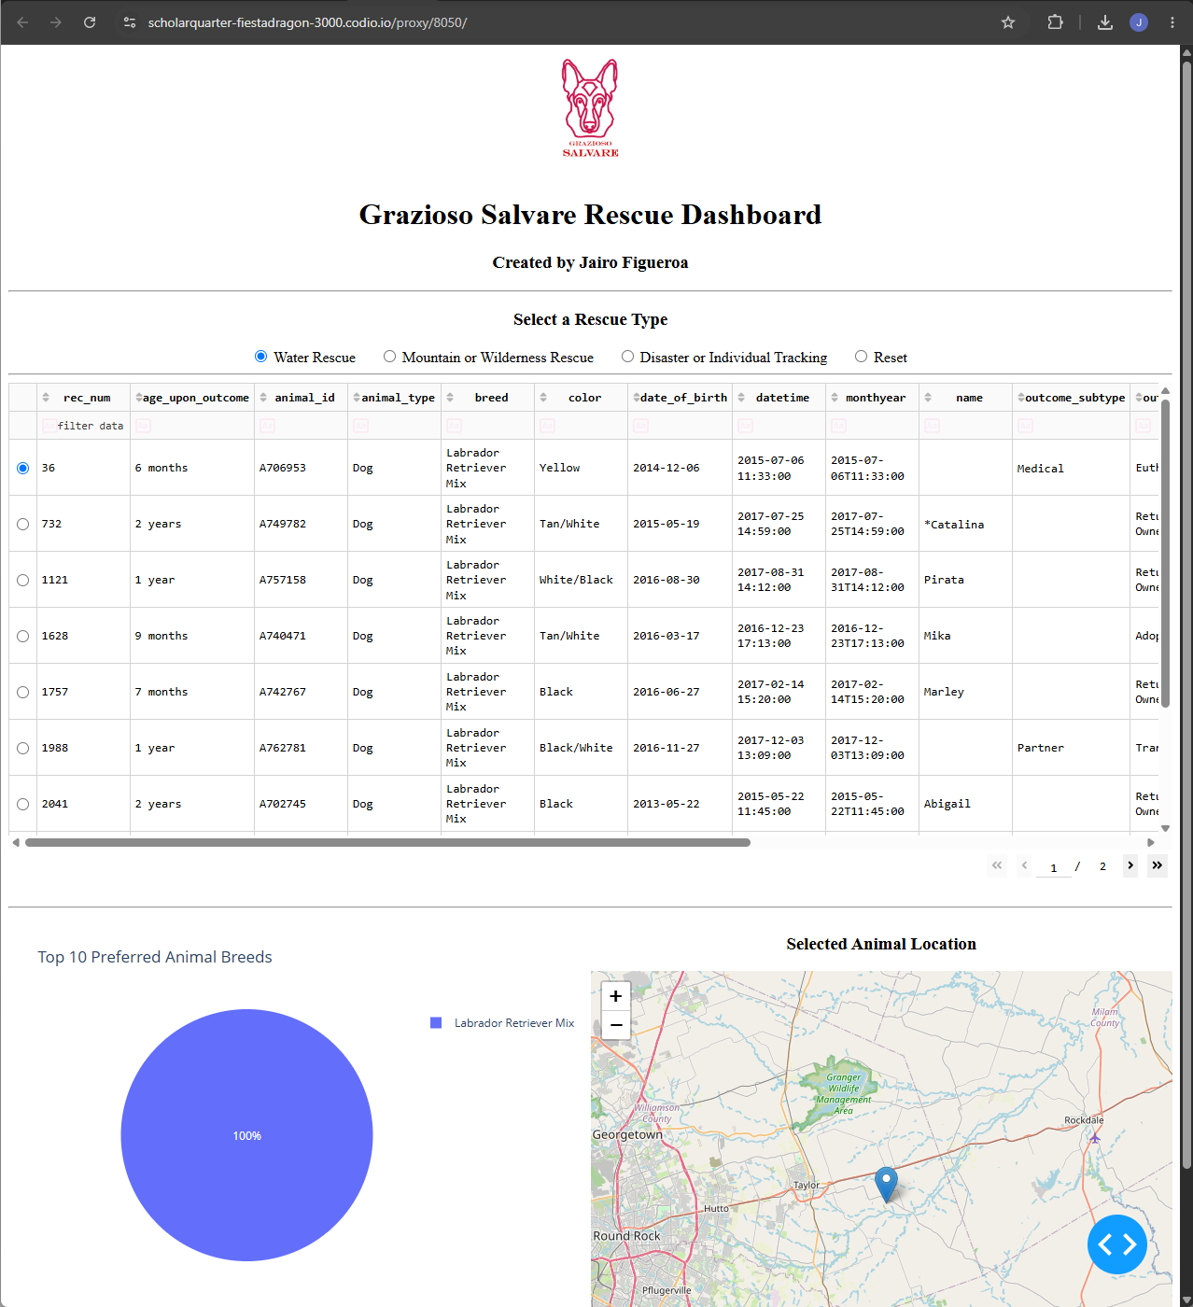

Figure. Dashboard with the Mountain or Wilderness Rescue filter selected.
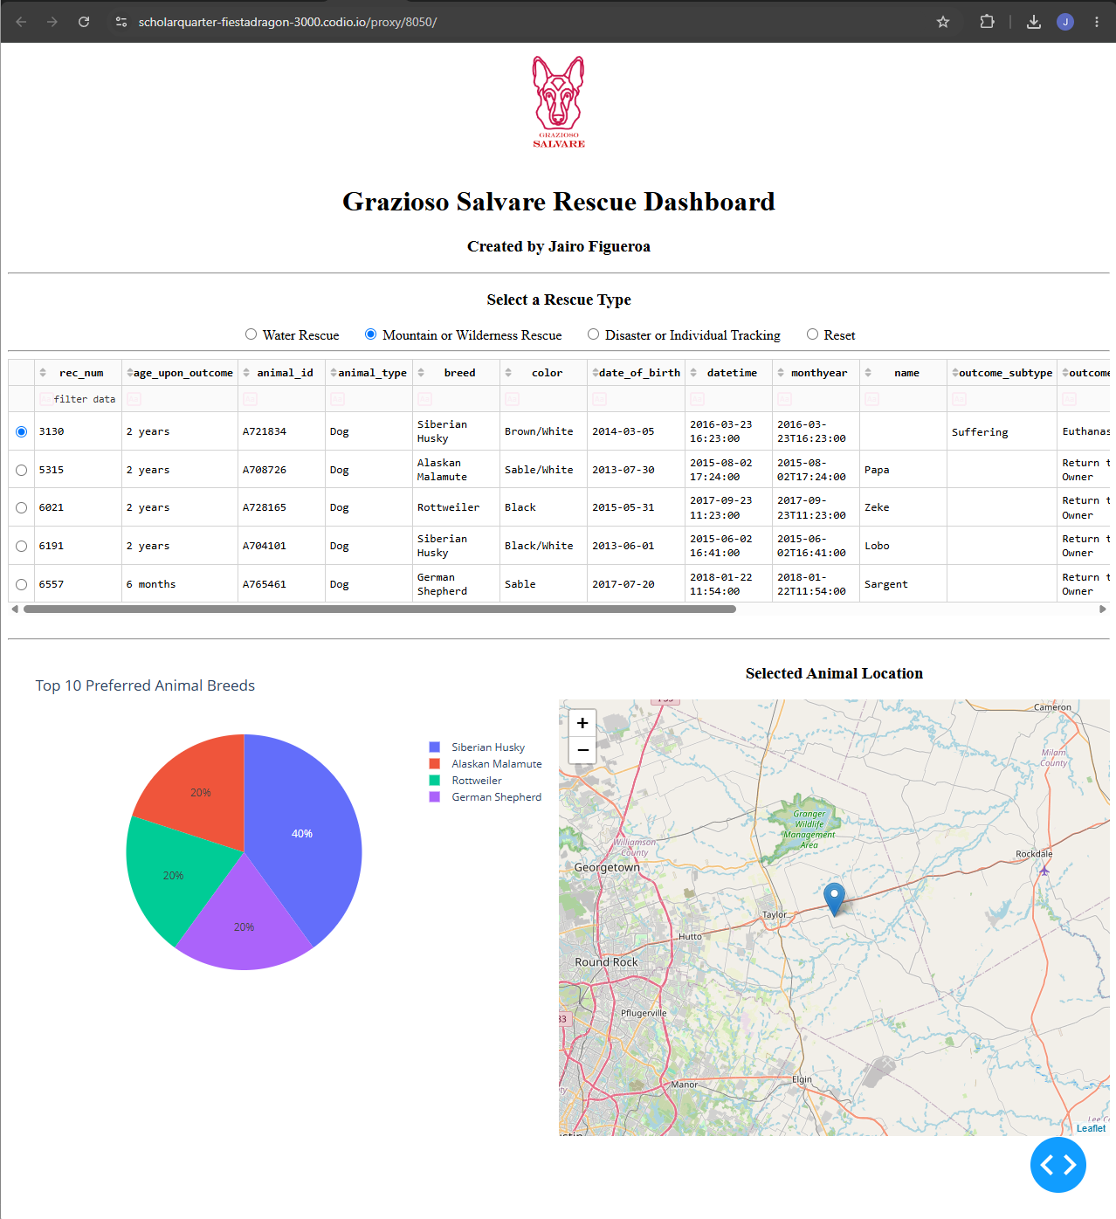

Figure. Dashboard with the Disaster or Individual Tracking filter selected
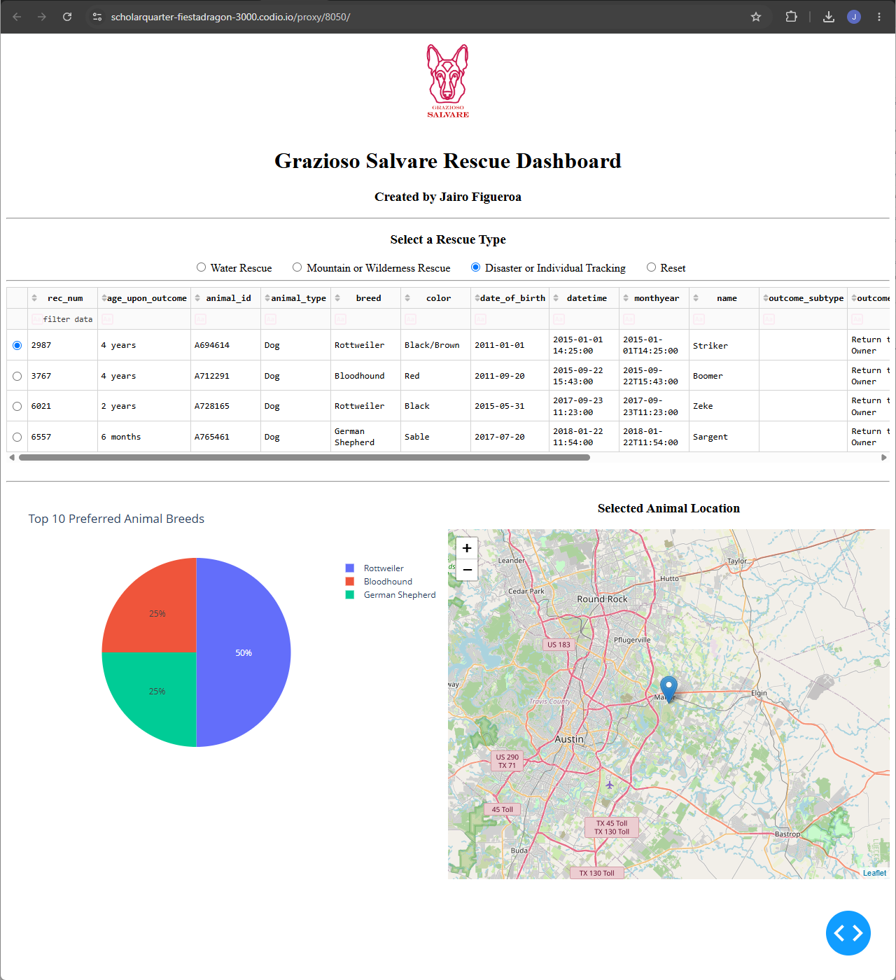

Challenges and Solutions
The first challenge I faced was linking the dashboard to MongoDB to ensure the CRUD module, username, password, database, and collection name were right. The solution to this challenge was checking the connection and ensuring the AnimalShelter class was getting records from the aac.animals collection. The second challenge was creating filters for rescues to match the specified breed, sex, and age range. This was solved by converting the challenge into a MongoDB query using $in, $gte, and $lte operators.
The next challenge was linking the data table, pie chart, and map to be updated when a filter is applied. This challenge was solved by using Dash callbacks that enabled filtered data from the table to control the other components on the dashboard. Another improvement in the dashboard included updating the pie chart to display only the ten most common breeds and renaming the columns in the map to location_lat and location_long.
Project Structure
ProjectTwoDashboard.ipynb – Holds code that includes the layout, MongoDB queries, callbacks, table, charts, maps, branding, and server code.
animal_shelter.py – Holds the AnimalShelter class and CRUD operations for the aac.animals collection.
Grazioso Salvare Logo.png – Holds the required branding logo for the dashboard.

Contact
Jairo Figueroa Rojas

